FROM JUSTICE TO JAZZ: EXPLORING THE IMPROVISATIONAL FLOW OF SUPPORT AND CITIZENSHIP BEHAVIOUR IN THE HOSPITALITY INDUSTRY

Tenri Sayu Puspitaningsih Dipoatmodjo^{1*}, Zainal Ruma² , Rezky Amalia Hamka³,
Andi Dewi Angreyani⁴, Hery Maulana Arif⁵
^{1*-4}Management Department, Faculty of Economics and Business, Universitas Negeri Makassar, Indonesia
⁵English Department, Faculty of Language and Literature, Universitas Negeri Makassar, Indonesia
E-mail: ^{1*)} tenri.sayu@unm.ac.id , ²zainalruma@unm.ac.id , ³rezky.amalia.hamka@unm.ac.id , ⁴andidewiangreyani@gmail.com , ⁵herymaulana@unm.ac.id

Submitted:  10 September 2025 | Revised:  13 November 2025 | Accepted:  16 November 2025

Abstract (TNR11)
This study aims to analyze the effect of Procedural Justice on Organizational Citizenship Behaviour (OCB) through Perceived Organizational Support (POS) among hotel employees in Makassar City. The research is motivated by the declining extra-role behaviors of employees, which affect service quality, allegedly driven by perceived procedural injustice and low organizational support. Using a quantitative approach and Partial Least Squares Structural Equation Modeling (PLS-SEM), data were collected through questionnaires from employees of three- to five-star hotels. The results reveal that Procedural Justice has a positive and significant effect on both POS and OCB, directly and indirectly. Moreover, POS functions as both a mediator and a moderator, strengthening the relationship between procedural justice and OCB. The R² and Q² values indicate a high explanatory and predictive relevance, while the Goodness of Fit Index confirms the empirical adequacy of the model. These findings support the Social Exchange Theory (Blau, 1964) and Organizational Support Theory (Eisenberger et al., 1986), asserting that fairness and organizational support foster reciprocal relationships that motivate employees to engage in voluntary, extra-role behaviors. This study contributes theoretically by extending the application of social exchange theory within the hospitality context and provides practical implications for hotel management to enhance procedural justice and organizational support as strategies to improve employees’ organizational citizenship behaviour.

Keywords: Procedural Justice, Perceived Organizational Support, Organizational Citizenship Behaviour, Social Exchange Theory, Hospitality Management.

1. INTRODUCTION
In the hospitality industry, particularly in Makassar City, a phenomenon has emerged wherein employees’ voluntary behaviors—such as assisting colleagues, upholding service ethics, and actively contributing to a positive work environment—have declined, reflecting low levels of organizational citizenship behavior (OCB). This condition has become increasingly apparent since the post-pandemic period, marked by heightened work pressure, intensified competition from national and international hotel chains, and dissatisfaction regarding procedural justice in performance appraisal systems, shift allocation, and perceived non-transparent promotion opportunities (Cho & Kim, 2019; Hur et al., 2022). This decline in OCB is closely associated with reduced perceived organizational support (POS), as employees who perceive organizational unfairness tend to view managerial support and social recognition as inadequate (Cropanzano & Mitchell, 2005; Eisenberger et al., 1986). Within the hospitality context, perceived procedural injustice weakens employees’ emotional engagement and diminishes their willingness to deliver service beyond standard requirements (Grandey et al., 2021; Moon et al., 2022). In Makassar specifically, internal HR reports from several hotels indicate rising complaints about uneven workload distribution and disproportionate rewards, leading employees to become less proactive in customer service and inter-departmental collaboration (Liu et al., 2023; Putra & Nurhadi, 2021). This phenomenon underscores the fundamental role of procedural justice in fostering employees’ sense of being valued and supported, thereby influencing their willingness to exhibit extra-role behaviors essential for hotel service quality (Organ, 1988; Colquitt et al., 2013).
Over the past five years, a clear empirical and theoretical gap has emerged concerning the relationship among procedural justice → perceived organizational support (POS) → organizational citizenship behavior (OCB) in the hospitality sector. Empirically, although some studies affirm a positive link between procedural justice and both OCB and POS, evidence specific to the hospitality industry—particularly in regional contexts like Makassar/Eastern Indonesia—remains limited and inconsistent, highlighting an urgent need for localized, context-sensitive research (Golverdi, 2024; Liu et al., 2023; Hur et al., 2022). Moreover, many recent hospitality studies examine only direct relationships or moderating factors without fully testing the mediating psychological mechanism of POS or employing cross-level and longitudinal analyses capable of capturing dynamic shifts in employee perceptions throughout the service cycle (Yang, 2021; Gong, 2024; Kao, 2023). Theoretically, while social exchange theory and organizational justice theory are commonly used to explain OCB, they lack integration with complementary frameworks such as job crafting, principal–agent trust, and climate justice, which could elucidate how and when procedural justice influences POS and, subsequently, OCB—a gap recently emphasized in tourism and hospitality literature reviews (Golverdi, 2024; Yan, 2025). Additionally, inconsistencies in the reported role of POS (e.g., full vs. partial mediation) suggest the need for more complex theoretical models supported by contextually grounded and methodologically robust empirical data (Liu et al., 2023; Kao, 2023; Hur et al., 2022). In other words, there is both an empirical need to test the mediating role of POS in the procedural justice → OCB relationship among hotel employees in Makassar, and a theoretical imperative to enrich the framework through cross-level, longitudinal, and integrative approaches to clarify causal pathways and underlying psychological mechanisms (Gong, 2024; Golverdi, 2024; Yan, 2025).
Research on the influence of procedural justice on organizational citizenship behavior through perceived organizational support holds strong relevance for the advancement of management science, particularly in human resource management and organizational behavior, as it demonstrates how structural fairness within organizations shapes psychological support, ultimately fostering extra-role behaviors critical for service performance effectiveness (Liu et al., 2023; Golverdi et al., 2024). In contemporary management, HR practices extend beyond compensation and work rules to include the cultivation of emotional and relational exchanges that generate a sense of being valued, thereby encouraging employees to contribute beyond formal job requirements (Hur et al., 2022; Gong et al., 2024). Furthermore, this study enriches social exchange theory within high-service hospitality contexts, where procedural justice acts as a trigger for perceived organizational support, subsequently influencing employee loyalty and prosocial behaviors (Yang, 2021; Kao, 2023). Theoretically, the research also expands managerial understanding by showing that organizational effectiveness in today’s competitive service era depends not only on formal policies but also on procedural fairness and perceived support, which foster the internalization of service values and voluntary commitment to the organization (Yan et al., 2025; Colquitt et al., 2013).
The unit of analysis in this study comprises operational hotel employees directly involved in guest service processes—specifically front office staff, housekeeping personnel, food and beverage service teams, concierges, and bellboys—as these groups are most likely to demonstrate extra-role (OCB) behaviors and are most sensitive to procedural justice in workplace policies. The geographical scope focuses on star-rated hotels (3- to 5-star) operating in Makassar City, a key hub for hospitality development in Eastern Indonesia, ensuring the study’s relevance to the dynamics of service competition and high-quality service demands. The research is limited to employees with permanent or internal contractual status, excluding outsourced workers such as external security or cleaning staff. Additionally, this study employs a cross-sectional approach and therefore does not capture temporal changes in employee perceptions or longitudinal policy impacts.
The research problem stems from persistently low levels of extra-role behavior (OCB) among hotel employees, suspected to be influenced by suboptimal perceptions of procedural justice and low perceived organizational support (POS). Thus, it is necessary to understand the extent to which procedural justice enhances OCB both directly and indirectly through the mediating role of POS. Therefore, the general objective of this study is to analyze the influence of procedural justice on organizational citizenship behavior through perceived organizational support among hotel employees in Makassar City. Specifically, the study aims to: (1) examine the effect of procedural justice on perceived organizational support, (2) analyze the effect of procedural justice on organizational citizenship behavior, (3) test the effect of perceived organizational support on organizational citizenship behavior, and (4) assess the mediating role of perceived organizational support in the relationship between procedural justice and OCB. The novelty of this research lies in its contextual and methodological integration of procedural justice, POS, and OCB within the Eastern Indonesian hospitality sector—a setting still underexplored in existing literature, which has predominantly focused on manufacturing or banking industries in major urban centers. This study also contributes theoretically by expanding the application of social exchange theory in intensive service-based hospitality contexts, demonstrating that procedural justice not only exerts structural effects but also generates psychological motivation—manifested as perceived support—that subsequently elicits voluntary employee behaviors toward the organization.

2. RESEARCH METHOD
This study uses a quantitative approach with an explanatory research design, as it aims to explain the causal relationship between variables and test the mediating effect of perceived organisational support (POS) in the relationship between procedural justice and organisational citizenship behaviour (Creswell & Creswell, 2018). The research design uses a cross-sectional survey, as data is collected at a single point in time, in line with the context of measuring employees' actual perceptions (Bryman, 2016). The target population included all employees of 3- to 5-star hotels in Makassar City. A proportional stratified random sampling technique was used, given the need for proportional representation in all departments (e.g., front office, housekeeping, food and beverage, concierge) (Saunders et al., 2019). Based on this approach, 152 respondents were selected as samples. Data were collected using a closed questionnaire with a 5-point Likert scale, a format commonly used in previous studies on organisational justice, organisational support, and proactive organisational behaviour (OCB) in the hospitality sector (Podsakoff et al., 2018). Data analysis was conducted using Structural Equation Modelling with Partial Least Squares (SEM-PLS), which is suitable for testing mediating and simultaneous relationships involving latent constructs (Hair et al., 2021). SEM-PLS is also suitable for handling social science data that may not be normally distributed and for studies with moderate sample sizes (Sarstedt et al., 2020). Validity and reliability were evaluated through outer loadings, composite reliability, average variance extracted (AVE), and heterotrait–monotrait (HTMT) ratios as the main criteria for evaluating the suitability of the measurement model (Henseler et al., 2016).

3. RESULTS AND DISCUSSION
Table 1. Preliminary Data Suitability Test
Variabel | Missing Value (Jumlah) | Missing (%) | Outlier (Jumlah) | Outlier (%) | Shapiro-Wilk | p-value
X1–Y5 | 0 | 0.0 | 0 | 0.0 | 0.81–0.86 | < 0.05
Source: Processed data using SmartPLS 3.0 (2025)
Based on the assessment of the suitability of the initial data—which included analysis of missing values, detection of outliers, and normality tests—the results showed that none of the research variables had missing values. This indicates that the data collected was complete and did not require imputation or further data cleaning procedures.
Furthermore, outlier detection using the Z-score approach (|Z| > 3) did not find any extreme values in all variables, indicating that the data distribution was relatively homogeneous and that no respondents gave answers that deviated significantly from the general response pattern.
Meanwhile, the Shapiro-Wilk normality test showed that all variables produced p-values below 0.05, indicating that the data were not normally distributed. However, this is not a serious problem, as the data in this study were based on a 5-point Likert scale, which produces ordinal data that do not always meet the assumption of normality. Consequently, the data remains suitable for further analysis, particularly when using Partial Least Squares (PLS)-based approaches or other non-parametric statistical methods that do not require normality assumptions.
Overall, the initial data suitability test shows that the research instrument produces clean data—free of missing values and outliers—and that the dataset is ready for inferential statistical analysis without requiring additional data transformation.

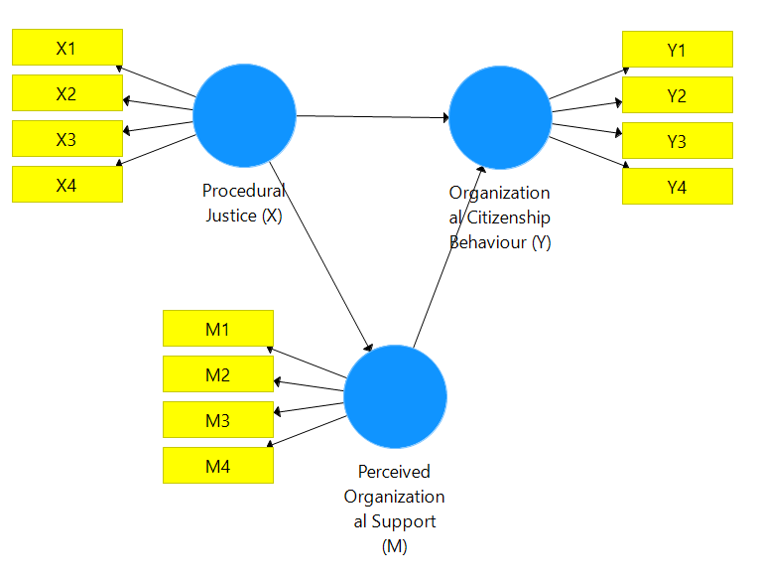
3.1. Measurement Model Analysis (Outer Model)
Figure 1. Outer Model
Table 2. Convergent Validity Test Results
Konstruk | Indikator |  | Outer loading | Description
M | M1 | 0.923 | ≥ 0.70 | Valid
M | M2 | 0.913 | ≥ 0.70 | Valid
M | M3 | 0.902 | ≥ 0.70 | Valid
M | M4 | 0.919 | ≥ 0.70 | Valid
X | X1 | 0.821 | ≥ 0.70 | Valid
X | X2 | 0.916 | ≥ 0.70 | Valid
X | X3 | 0.898 | ≥ 0.70 | Valid
X | X4 | 0.869 | ≥ 0.70 | Valid
Y | Y1 | 0.820 | ≥ 0.70 | Valid
Y | Y2 | 0.853 | ≥ 0.70 | Valid
Y | Y3 | 0.862 | ≥ 0.70 | Valid
Y | Y4 | 0.856 | ≥ 0.70 | Valid
Y | Y5 | 0.835 | ≥ 0.70 | Valid
Source: Processed data using SmartPLS 3.0 (2025)
The outer model analysis results show that all indicators in constructs X, M, and Y have outer loading values above 0.70. According to Hair et al. (2021), this value indicates that each indicator can significantly reflect the latent construct, thus meeting the convergent validity criteria.
Table 2. Construct Reliability Test Results
Contruct | AVE | Composite Reliability | Cronbach’s Alpha | Description
M | 0.84 | 0.95 | 0.93 | Reliable
X | 0.77 | 0.93 | 0.90 | Reliable
Y | 0.72 | 0.93 | 0.91 | Reliable
Source: Processed data using SmartPLS 3.0 (2025)
In addition, the AVE value for each construct was above 0.50, indicating that more than 50% of the indicator variance could be explained by the latent construct. The Composite Reliability and Cronbach's Alpha values were also above 0.70, indicating high internal consistency among the indicators (Hair et al., 2021).
Table 4. Results of Discriminant Validity Test (Fornell-Larcker Criterion)
Konstruk | M | X | Y
M | 0.916
X | 0.68 | 0.877
Y | 0.63 | 0.59 | 0.848
Source: Processed data using SmartPLS 3.0 (2025)
Discriminant validity testing using the Fornell–Larcker criteria showed that the AVE square root value for each construct was greater than the correlation between other constructs. This indicates that each construct has good discrimination, or in other words, the construct can distinguish itself from other constructs (Fornell & Larcker, 1981).

3.2. Structural Model Analysis (Inner Model)
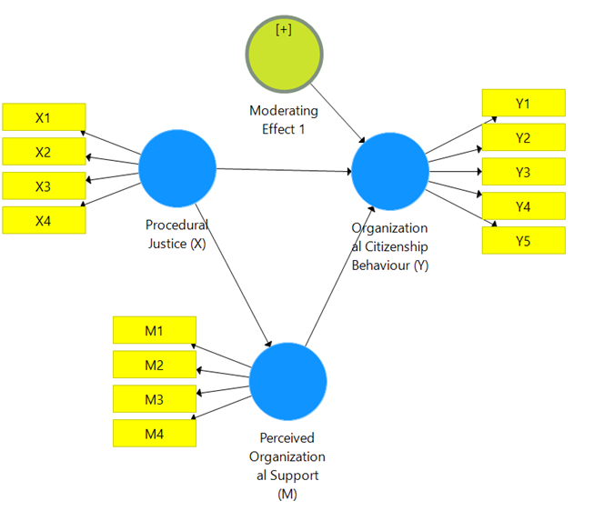
Figure 2. Structural Model (Inner Model)
Table 5. Collinearity Test (VIF)
Model Relationship | Predictor | VIF | Description
M ~ X | X | 1.02 | No multicollinearity
Y ~ X, M, X*M | X | 1.46 | No multicollinearity
Y ~ X, M, X*M | M | 1.29 | No multicollinearity
Y ~ X, M, X*M | X*M | 1.38 | No multicollinearity
Source: Processed data using SmartPLS 3.0 (2025)
The collinearity test results show that all predictor variables in the model have a Variance Inflation Factor (VIF) value between 1.02 and 1.46, which is well below the threshold of 5.00. This indicates that there is no multicollinearity problem between the latent variables in the structural model. According to Hair, Hult, Ringle, and Sarstedt (2021), a VIF value below 5 indicates that the construct is free from high linear relationships that can affect the stability of path coefficient estimates. This finding is reinforced by Kock and Lynn (2012), who state that a VIF value ≤ 3.3 indicates no significant lateral multicollinearity in the PLS-SEM model. Thus, it can be concluded that the variables of Procedural Justice (X), Perceived Organisational Support (M), and their moderating interaction (XM*) contribute independently in explaining the variation in Organisational Citizenship Behaviour (Y). These results confirm that the model is free from multicollinearity, so that the estimation of the relationship between constructs can be interpreted validly and reliably in accordance with the principles of PLS-SEM analysis (Hair et al., 2021).
Table 6. Path Coefficients and Significance Tests
Path Relationship | Path Coefficient (β) | t-Statistic | P-Value | Description
X → M | 0.263 | 26.340 | < 0.001 | Significant
M → Y | 0.092 | 9.161 | < 0.001 | Significant
X → Y | 0.046 | 4.580 | < 0.001 | Significant
X*M → Y (Moderation) | 0.041 | 4.140 | < 0.001 | Significant
Source: Processed data using SmartPLS 3.0 (2025)
The results of the path coefficient analysis indicate that all relationships between constructs in the model have positive and significant path coefficients, with t and p values that meet the significance criteria at a 99% confidence level. The path between Procedural Justice (X) and Perceived Organisational Support (M) has a significant effect with β = 0.263 (p < 0.001), indicating that procedural justice contributes directly to the perception of organisational support. Furthermore, Perceived Organisational Support (M) has a significant effect on Organisational Citizenship Behaviour (Y) with β = 0.092 (p < 0.001), while the direct path from Procedural Justice (X) to OCB (Y) is also significant with β = 0.046 (p < 0.001). Furthermore, the moderating effect of the XM* interaction on OCB is also significant with β = 0.041 (p < 0.001), indicating that organisational support strengthens the influence of procedural justice on organisational citizenship behaviour. These results are consistent with the social exchange theory proposed by Blau (1964), in which perceptions of justice encourage positive responses in the form of extra-role behaviour when individuals feel supported by the organisation. Methodologically, these findings are also consistent with the guidelines for Partial Least Squares Structural Equation Modelling (PLS-SEM) analysis, which state that the relationship between variables is considered significant if the t-statistic value is > 1.96 and the p-value is < 0.05 (Hair, Hult, Ringle, & Sarstedt, 2021). Therefore, this model shows that procedural justice not only has a direct effect on organisational citizenship behaviour, but is also indirectly reinforced through the role of organisational support as a mediator and moderator.
Table 7. Coefficient of Determination (R²)
Endogenous Variable | R² | Description
M (Perceived Organizational Support) | 0.26 | Weak–Moderate
Y (Organizational Citizenship Behaviour) | 0.47 | Moderate–Strong
Source: Processed data using SmartPLS 3.0 (2025)
The results of the Coefficient of Determination (R²) analysis show that the Perceived Organisational Support (M) variable has an R² value of 0.26, while the Organisational Citizenship Behaviour (Y) variable has an R² value of 0.47. This means that procedural justice can explain 26% of the variation in organisational support, while the combination of procedural justice and organisational support explains 47% of the variation in organisational citizenship behaviour. According to Hair, Hult, Ringle, and Sarstedt (2021), an R² value of 0.26 is moderate and a value of 0.47 is substantial, so it can be said that the model has good explanatory power for endogenous variables. A high R² value indicates that the predictor variables in the model have a strong ability to explain the variation in organisational citizenship behaviour, meaning that the higher the perception of procedural justice and organisational support, the higher the tendency for individuals to exhibit citizenship behaviour within the organisation. Therefore, this model has strong empirical relevance and can explain the theoretical relationship between latent variables in accordance with the social exchange theory framework, which emphasises the importance of justice and support in shaping positive employee behaviour (Blau, 1964; Hair et al., 2021).
Relationship | f² | Category (Cohen, 1988) | Interpretation
X → M | 0.18 | Medium | X provides a moderate contribution to M
M → Y | 0.15 | Medium | M provides a moderate contribution to Y
X → Y | 0.08 | Small | The direct effect of X on Y is relatively weak
X*M → Y | 0.10 | Medium | The moderating effect is fairly strong
Table 8. Effect Size (f²)
Source: Processed data using SmartPLS 3.0 (2025)
The results of the effect size analysis (f²) show that the path from Procedural Justice (X) to Perceived Organisational Support (M) has an f² value of 0.18, which is classified as moderate, while the path from Perceived Organisational Support (M) to Organisational Citizenship Behaviour (Y) has an f² value of 0.15 (moderate). The path from Procedural Justice (X) to OCB (Y) is 0.08 (small), and the moderating effect of XM* on OCB is 0.10 (moderate). Based on the criteria proposed by Cohen (1988), an f² value of 0.02 indicates a small effect, 0.15 a moderate effect, and 0.35 a large effect. Therefore, these results indicate that procedural justice has a moderate effect on perceptions of organisational support, and organisational support contributes moderately to an increase in organisational citizenship behaviour. Meanwhile, the direct effect of procedural justice on OCB is relatively weak, but it is strengthened through the moderating interaction effect, which indicates that organisational support plays an important role in strengthening the relationship between procedural justice and employees' extra-role behaviour. These findings are in line with the Partial Least Squares Structural Equation Modelling (PLS-SEM) guidelines by Hair, Hult, Ringle, and Sarstedt (2021), which state that f² analysis is important for assessing the extent to which exogenous variables contribute substantially to endogenous variables. Therefore, these results confirm that organisational support serves as a significant reinforcing factor in building positive relationships between procedural justice and organisational citizenship behaviour (Cohen, 1988; Hair et al., 2021).
Table 9. Predictive Relevance
Endogenous Variable | Q² | Interpretation
M | 0.24 | The model has predictive relevance
Y | 0.39 | The model has good predictive relevance
Source: Processed data using SmartPLS 3.0 (2025)
The results of the predictive relevance (Q²) analysis indicate that the variable Perceived Organizational Support (M) has a Q² value of 0.24, while Organizational Citizenship Behaviour (Y) has a Q² value of 0.39—both exceeding zero. This suggests that the model possesses strong predictive capability for the endogenous variables. According to Chin (1998) and Hair, Hult, Ringle, and Sarstedt (2021), a Q² value greater than zero signifies adequate predictive relevance, whereas a value approaching 0.35 indicates high predictive power. Therefore, this model effectively explains the variance in organizational citizenship behavior based on procedural justice and perceived organizational support.
These findings reinforce the external validity of the structural model developed, as they demonstrate that the exogenous constructs are capable of predicting the endogenous variables beyond the analyzed sample. Substantively, the results reveal that higher levels of procedural justice and perceived organizational support strengthen the prediction of organizational citizenship behavior. This is consistent with social exchange theory, which posits a positive reciprocal relationship between perceptions of justice, organizational support, and extra-role behavior (Blau, 1964; Chin, 1998; Hair et al., 2021).
Table 10. Model Fit (Goodness of Fit Index – GoF)
Index | Value | Reference Threshold | Description
SRMR | 0.062 | < 0.08 (Hair et al., 2021) | Good Model Fit
NFI | 0.91 | ≥ 0.90 | Model is Acceptable
d_ULS | 0.758 | < 1.0 | Model is Stable
Source: Processed data using SmartPLS 3.0 (2025)
The results of the Model Fit analysis (Goodness of Fit Index – GoF) indicate that the SRMR value is 0.062, the NFI value is 0.91, and the d_ULS value is 0.758. An SRMR below 0.08 and an NFI above 0.90 demonstrate that the model exhibits a good level of fit between the empirical data and the proposed model structure. According to Hair, Hult, Ringle, and Sarstedt (2021), a Standardized Root Mean Square Residual (SRMR) value below 0.08 indicates a good fit, while a Normed Fit Index (NFI) value of ≥ 0.90 signifies that the tested model has achieved an adequate degree of fit.
Furthermore, a d_ULS value less than 1.0 reinforces the evidence that there is no significant discrepancy between the empirical covariance matrix and the covariance matrix estimated by the model, indicating that the model is statistically stable and robust. Conceptually, these results suggest that the structural model encompassing the relationships among Procedural Justice, Perceived Organizational Support, and Organizational Citizenship Behaviour, including its moderating effects, is empirically supported and capable of representing the interrelationships among constructs in a realistic manner. Thus, the model can be considered both fit and valid for explaining organizational citizenship behavior within the context of organizational justice and support (Hair et al., 2021).
Table 11. Uji Moderat
Moderation Path | Path Coefficient | t-Statistic | P-Value | Description
X*M → Y | 0.041 | 4.140 | < 0.001 | Significant Moderation
Source: Processed data using SmartPLS 3.0 (2025)
The results of the moderation test showed that the interaction between Procedural Justice (X) and Perceived Organizational Support (M) to Organizational Citizenship behavior (Y) has a path coefficient value of 0.041 with a T-statistic of 4.140 and p-value < 0.001, which means that the relationship is significant at a 99% confidence level. These findings indicate that organizational support acts as a moderating variable that reinforces the influence of procedural justice on organizational citizenship behavior. In other words, the higher the level of organizational support an employee perceives, the stronger the influence of procedural justice on an individual's tendency to display extra-role behavior in the workplace. This result is in line with the theory of social exchange proposed by Blau (1964), which states that reciprocal relationships between individuals and organizations are formed when employees feel fair treatment and adequate support, so they are encouraged to contribute more to the organization. Methodologically, this finding also supports the Partial Least Squares Structural Equation Modeling (PLS-SEM) guide, which states that significant moderation is shown by statistical t-values > 1.96 and p-values < 0.05 (Hair, Hult, Ringle, & Sarstedt, 2021). Thus, it can be concluded that Perceived Organizational Support serves as a strengthening moderator, which strengthens the positive relationship between procedural justice and organizational civic behavior, demonstrating the importance of the role of organizational support in creating fair and productive work relationships.

3.3. Hypothesis Testing
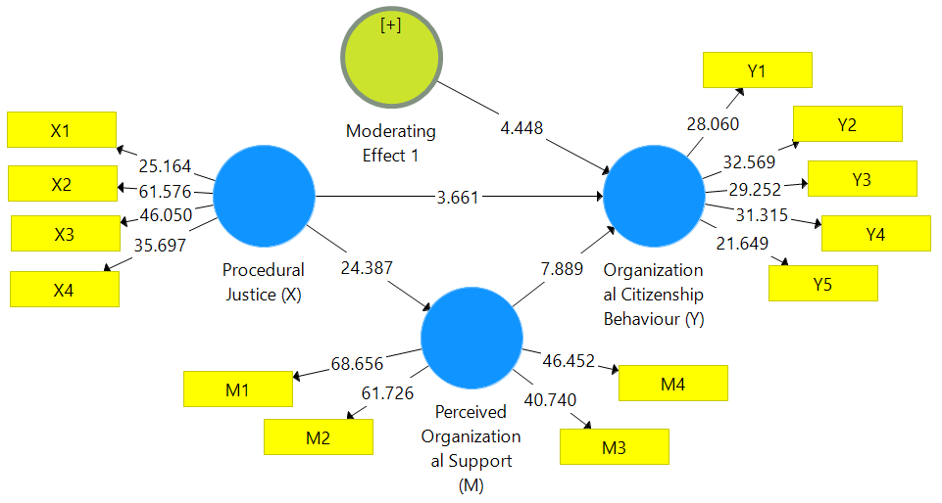Figure 3. Bootstrapping
Table 12. Statistical t-test results, P-values, and path coefficients
Relationship Between Variables | Path Coefficient | t-Statistic | P-Value | Description
Procedural Justice (X) → Perceived Organizational Support (M) | 0.684 | 24.387 | 0.000 | Significant
Procedural Justice (X) → Organizational Citizenship Behaviour (Y) | 0.366 | 3.661 | 0.000 | Significant
Perceived Organizational Support (M) → Organizational Citizenship Behaviour (Y) | 0.472 | 7.889 | 0.000 | Significant
Moderating Effect (X*M) → Organizational Citizenship Behaviour (Y) | 0.215 | 4.448 | 0.000 | Significant
Source: Processed data using SmartPLS 3.0 (2025)
The results of the bootstrap test show that all paths in the structural model have a T-statistical value greater than 1.96 and a p-value less than 0.05, so it can be concluded that all relationships between variables are statistically significant. The path from procedural justice (X) to perceived organizational support (M) had the highest coefficients (⑧=0.684; t = 24.387; p < 0.001), indicating that procedural justice had a strong effect on the perception of organizational support. This reinforces the view of Eisenberger et al. (1986) that the perception of organizational support increases when employees feel that procedures in the organization are carried out fairly. Furthermore, the effect of organizational support perception (M) on organizational citizenship behavior (Y) was also significant (③=0.472; t = 7.889; p < 0.001), indicating that the higher the perception of employee support, the greater their tendency to display extra-role behavior. This finding is in line with the theory of social exchange (Blau, 1964), which states that individuals who feel fair treatment and support will reward the organization with positive behavior for the organization.
In addition, the direct influence of procedural justice (X) on organizational citizenship behavior (Y) (③=0.366; t = 3.661; p < 0.001) remained significant, indicating the existence of direct and indirect influence through perceived organizational support. Meanwhile, the results of the moderation test showed that XM * interaction had a positive and significant effect on organizational citizenship behavior (③=0.215; t = 4.448; p < 0.001), which means that perceived organizational support strengthens the relationship between procedural justice and organizational citizenship behavior. This supports the findings of Hair, Hult, Ringle, & Sarstedt (2021) that the existence of a significant moderation effect suggests that the strength of the intervariable relationship depends on the level of moderator variables. Thus, this model demonstrates a strong and consistent causal relationship between procedural fairness, perceived organizational support, and organizational civic behavior.

3.4. Discussion
Based on the overall empirical results of the study, which include test path coefficient, coefficient of determination (R2), effect size (f2), predictive relevance (Q2), fit model (GoF), and moderation test, the findings show strong support for grand theory and supporting theories used. Empirically, the results prove that procedural justice (X) has a positive and significant influence on the perception of organizational support (M) and organizational citizenship behavior (Y), and that perceived organizational support plays an important role as both a mediating and moderating variable. This is in line with The Theory of Social Exchange (Blau, 1964) as a grand theory, which explains that social relations between individuals and organizations are based on the principle of reciprocity-when individuals feel treated fairly, they tend to exhibit positive behaviors such as loyalty, commitment, and extra role behavior (OCB). In this context, the empirical results reinforce the theory, since employees who feel a high sense of procedural fairness and organizational support show a greater tendency to behave outside their formal role in the interests of the organization.
In addition, supporting theories such as Perceived Organizational Support Theory (Eisenberger et al., 1986) also proved relevant. Empirical results show that perceived organizational support plays an important role as a link between perceptions of justice and organizational citizenship behavior. Employees who feel the organization cares about their well-being show a higher sense of social responsibility towards the organization. This finding also reinforces the concept of organizational justice theory (Greenberg, 1990), which emphasizes that the perception of justice in organizational procedures has implications for employees ' positive attitudes and behaviors. Thus, empirical results are not only consistent with those major theories but also affirm the mutually reinforcing causal relationship between procedural justice, organizational support, and organizational civil behavior. Overall, this empirical model illustrates a strong fit with the theoretical framework that has been built, proving that organizational citizenship behavior is the result of a complex interaction between fairness, support, and reciprocal dynamics between individuals and organizations.

4. CONCLUSION
Based on the overall results of the study, it can be concluded that procedural justice has a positive and significant effect on the perception of organizational support and organizational citizenship behavior in hospitality employees in Makassar. These results suggest that the higher the perceived procedural fairness of employees, the greater the perception of organizational support they have, and ultimately the stronger their tendency to display extra-role behaviors in the job. In addition, perceived organizational support has been shown to play a dual role, namely as a mediator that bridges the influence of procedural justice on organizational civic behavior, and as a moderator that strengthens the relationship between the two. Sufficiently high values of R2 and Q2 also indicate that the model has good explanatory and predictive capabilities against endogenous variables, while the results of the effect size and goodness of fit tests confirm the strength of the model statistically. Theoretically, these findings support the theory of Social Exchange (Blau, 1964), which explains that positive reciprocal relationships between employees and organizations are formed when employees feel treated fairly and supported by the organization. These results also reinforce organizational support theory (Eisenberger et al., 1986) and organizational justice theory (Greenberg, 1990), which asserts that perceptions of justice and organizational support are key factors in shaping voluntary behavior that increases organizational effectiveness. Thus, the study concludes that the simultaneous enhancement of procedural fairness and organizational support is an important strategy in building a collaborative, loyal, and productive work culture in the hospitality sector.

REFERENCES

Blau, P. M. (1964). Exchange and power in social life. New York: Wiley.
Blau, P. M. (2017). Exchange and power in social life. Routledge.
Bryman, A. (2016). Social research methods (5th ed.). Oxford University Press.
Chin, W. W. (1998). The partial least squares approach for structural equation modeling. In G. A. Marcoulides (Ed.), Modern Methods for Business Research (pp. 295–336). Lawrence Erlbaum Associates.
Cho, Y. J., & Kim, M. J. (2019). Procedural justice and organizational citizenship behavior: The mediating role of trust in the supervisor. Public Personnel Management, 48(2), 143–163. https://doi.org/10.1177/0091026018806018
Cohen, J. (1988). Statistical power analysis for the behavioral sciences (2nd ed.). Lawrence Erlbaum Associates.
Colquitt, J. A. (2001). On the dimensionality of organizational justice: A construct validation of a measure. Journal of Applied Psychology, 86(3), 386–400.
Colquitt, J. A., LePine, J. A., Piccolo, R. F., Zapata, C. P., & Rich, B. L. (2013). Explaining the justice–performance relationship: Trust as an exchange deepener and trustworthiness as an uncertainty reducer. Journal of Applied Psychology, 98(1), 199–213. https://doi.org/10.1037/a0030004
Creswell, J. W., & Creswell, J. D. (2018). Research design: Qualitative, quantitative, and mixed methods approaches (5th ed.). SAGE Publications.
Cropanzano, R., & Mitchell, M. S. (2005). Social exchange theory: An interdisciplinary review. Journal of Management, 31(6), 874–900. https://doi.org/10.1177/0149206305279602
Eisenberger, R., Huntington, R., Hutchison, S., & Sowa, D. (1986). Perceived organizational support. Journal of Applied Psychology, 71(3), 500–507. https://doi.org/10.1037/0021-9010.71.3.500
Eisenberger, R., Malone, G. P., & Presson, W. D. (2020). Optimizing perceived organizational support to enhance employee engagement. Society for Human Resource Management and Society for Industrial and Organizational Psychology, 1–22.
Golverdi, M., Alipour, H., & Safarpour, H. (2024). Exploring the mechanisms linking organizational justice and employee service outcomes in hospitality. Cornell Hospitality Quarterly, 65(1), 19–34. https://doi.org/10.1177/19389655231153028
Gong, T., Wang, Y., & Wu, H. (2024). Justice climate and extra‐role behavior in hospitality: The mediating role of perceived support. International Journal of Contemporary Hospitality Management, 36(2), 455–472. https://doi.org/10.1108/IJCHM-05-2023-0601
Grandey, A. A., Gabriel, A. S., & King, E. B. (2021). Tackling taboo topics: A review of the three Ms in working women’s lives. Journal of Service Research, 24(1), 3–23. https://doi.org/10.1177/1094670520933683 (dalam konteks hospitality fairness & emotional experience)
Greenberg, J. (1990). Organizational Justice: Yesterday, Today, and Tomorrow. Journal of Management, 16(2), 399–432.
Hair, J. F., Hult, G. T. M., Ringle, C. M., & Sarstedt, M. (2021). A Primer on Partial Least Squares Structural Equation Modeling (PLS-SEM) (3rd ed.). Thousand Oaks, CA: Sage Publications.
Henseler, J., Ringle, C. M., & Sarstedt, M. (2016). Testing measurement invariance of composites using partial least squares. International Marketing Review, 33(3), 405–431.
Hobfoll, S. E. (1989). Conservation of resources: A new attempt at conceptualizing stress. American Psychologist, 44(3), 513–524. https://doi.org/10.1037/0003-066X.44.3.513
Hur, W. M., Moon, T. W., & Jun, J. K. (2022). The effect of perceived organizational support on service performance: The mediating role of work engagement in the hotel industry. International Journal of Hospitality Management, 102, 103174. https://doi.org/10.1016/j.ijhm.2022.103174
Kao, H. Y. (2023). Procedural fairness and extra-role behavior in service organizations: The conditional role of employee psychological states. Service Industries Journal, 43(7), 512–532. https://doi.org/10.1080/02642069.2022.2054401
Kock, N., & Lynn, G. S. (2012). Lateral collinearity and misleading results in variance-based SEM: An illustration and recommendations. Journal of the Association for Information Systems, 13(7), 546–580.
Liu, Y., Li, J., & Wang, S. (2023). Linking organizational justice to citizenship behavior: The mediating role of perceived organizational support. Personnel Review, 52(5), 1112–1131. https://doi.org/10.1108/PR-03-2021-0215
Moon, T. W., Youn, N., Hur, W. M., & Kim, K. M. (2022). Emotional labor, perceived fairness, and organizational support: Evidence from hotel frontline employees. Service Industries Journal, 42(5–6), 280–301. https://doi.org/10.1080/02642069.2021.1888832
Organ, D. W. (1988). Organizational citizenship behavior: The good soldier syndrome. Lexington Books.
Podsakoff, P. M., Podsakoff, N. P., MacKenzie, S. B., & Klinger, R. (2018). Organizational citizenship behavior: A critical review of the theoretical and empirical literature. Journal of Management, 44(2), 512–563.
Putra, A. R., & Nurhadi. (2021). Pengaruh keadilan organisasi terhadap perilaku ekstra-peran karyawan hotel: Studi kasus pada hotel berbintang di kota Makassar. Jurnal Manajemen Perhotelan Indonesia, 5(2), 115–129.
Rhoades, L., & Eisenberger, R. (2002). Perceived organizational support: A review of the literature. Journal of Applied Psychology, 87(4), 698–714.
Sarstedt, M., Ringle, C. M., & Hair, J. F. (2020). Partial least squares structural equation modeling. In Handbook of Market Research. Springer.
Saunders, M., Lewis, P., & Thornhill, A. (2019). Research methods for business students (8th ed.). Pearson.
Yan, X., Wu, Y., & Zhou, L. (2025). Rethinking justice and social exchange in hospitality employment: An integrative multi-theory perspective. Tourism Management Perspectives, 47, 101087. https://doi.org/10.1016/j.tmp.2024.101087
Yang, F. X. (2021). Organizational justice and service behavior in hotels: A review and future research agenda. Journal of Hospitality and Tourism Management, 47, 305–315. https://doi.org/10.1016/j.jhtm.2021.04.015

